TECHNICAL PROPOSAL
Moodle Automatic Course
Progress Reset Plugin
Scheduled quiz-attempt monitoring, full learner progress reset, re-enrolment continuity, notification and audit logging

Prepared By
Riseup Labs


Table of Contents
1. Executive Summary 3
2. Project Understanding and Objectives 3
2.1 Project Understanding 3
2.2 Objectives 3
3. Confirmed Scope Parameters 3
4. Functional Scope and Feature List 4
4.1 Plugin Configuration and Course Selection 4
4.2 Scheduled Monitoring and Eligibility Detection 4
4.3 Course Progress Reset and Enrolment Continuity 4
4.4 Student Notification and Audit Logging 4
5. Role-Based User Journeys 5
5.1 Moodle Site Administrator / Authorized Course Administrator 5
5.2 Student / Employee 5
6. Operational Workflows 5
6.1 Approved Course Identification Workflow 5
6.2 Learner Eligibility Workflow 5
6.3 Reset Execution Workflow 5
6.4 Failure and Retry Workflow 6
7. Proposed Technical Approach 6
7.1 Plugin Architecture 6
7.2 Scheduled Processing Design 6
7.3 Eligibility Rules 6
7.4 Reset Data Strategy 7
7.5 Activity Compatibility Validation 7
7.6 Notification and Audit Design 7
8. Technical Architecture 8
8.1 High-Level Solution Architecture 8
8.2 Scheduled Task Processing Flow 9
9. Proposed Technical Stack 9
10. Development Methodology 10
11. Deliverables 10
12. Testing and Quality Assurance 10
12.1 Test Strategy 10
12.2 Unit Testing 10
12.3 Integration Testing 11
12.4 Negative and Edge-Case Testing 11
12.5 Performance and Reliability Testing 11
12.6 Security and Data Integrity Testing 11
13. Deployment and Release Approach 11
14. Assumptions and Dependencies 12
15. Out of Scope 12
16. Acceptance Criteria 12
17. Conclusion 13

1. Executive Summary
This proposal presents the design and implementation approach for a Moodle local plugin that automatically resets a learner’s complete course progress when the learner has exhausted the permitted attempts in at least one quiz and has not achieved the configured passing grade.
The plugin will operate as a Moodle Scheduled Task. It will process only courses whose course custom field “Approved” is set to “yes”, evaluate enrolled students, remove the identified learner’s course-specific academic history, re-establish the original enrolment relationship, notify the affected student, and retain an administrative audit record of the reset action.

2. Project Understanding and Objectives

2.1 Project Understanding
The current requirement is to automate a repeat-learning process for employees who fail a quiz after using all allowed attempts. Instead of relying on a manual administrator action, Moodle cron will periodically identify eligible learners and reset the complete course participation data for those learners.

2.2 Objectives
• Automatically identify failed learners who have no remaining quiz attempts.
• Restrict monitoring to approved courses only.
• Reset the learner’s entire course progress and user-specific activity history.
• Maintain continuity of the original enrolment method, including Manual, Cohort and Cohort Sync enrolments.
• Notify only the student whose course progress has been reset.
• Retain reliable audit evidence for each reset action.
• Validate the solution in a staging environment before release.

3. Confirmed Scope Parameters
Category | Confirmed Requirement
Moodle Version | Moodle 5.2
PHP / Server Runtime | PHP 8.4.7, 64-bit
Database | PostgreSQL 16.8
Supported Enrolment Methods | Manual, Cohort and Cohort Sync
Courses to Monitor | Courses where the custom field “Approved” is set to “yes”
Passing Criteria | Quiz passing grade configured in Moodle
Reset Trigger | The student has no remaining attempts and has a failing grade
Reset Scope | Entire course progress and all user-specific activity data
User Notification | Only the affected student receives a reset notification
Audit Log Policy | All reset actions are retained in audit logs
Staging Environment | Required

4. Functional Scope and Feature List
The functional breakdown below is intentionally limited to the provided requirement. Each feature is implemented within a single Moodle plugin and uses existing Moodle administration, cron, enrolment, grading and messaging capabilities.

4.1 Plugin Configuration and Course Selection
• Provide the plugin as an installable Moodle local plugin.
• Declare a default scheduled-task frequency and allow an administrator to adjust the schedule through Moodle Scheduled Tasks configuration.
• Identify only courses where the course custom field “Approved” has the value “yes”.
• Exclude courses that do not meet the approved-course condition.
• Use existing Moodle permissions so configuration remains restricted to authorized administrators.

4.2 Scheduled Monitoring and Eligibility Detection
• Run automatically through Moodle cron at the configured interval.
• Retrieve active enrolled students from each approved course.
• Review quiz activities configured in the course.
• Read the learner’s completed attempt count and the quiz maximum-attempt limit.
• Read the quiz grade and the configured passing grade.
• Mark a learner as eligible only when the maximum allowed attempts have been reached or exceeded and the learner has not passed.
• Ignore quizzes with unlimited attempts for reset-trigger purposes.
• Continue scanning remaining users and courses when one record cannot be processed, while logging the error.

4.3 Course Progress Reset and Enrolment Continuity
• Capture the learner’s current enrolment method, enrolment instance, course role and relevant enrolment dates before reset.
• Unenrol or safely detach the learner’s course participation through the relevant Moodle enrolment API.
• Delete the learner’s quiz attempts within the course.
• Delete course and activity grade records for the learner and prevent restoration of previous grades during re-enrolment.
• Clear activity completion, course completion, progress percentage and other learner-specific course activity records.
• Remove stored user progress associated with the course while preserving restricted reset audit evidence.
• Re-establish the learner’s access through the same enrolment relationship, including Manual, Cohort or Cohort Sync.
• Ensure the learner returns to the course with 0% progress, no completed activities, no attempts and no grades.

4.4 Student Notification and Audit Logging
• Send a Moodle notification only after a learner reset has completed successfully.
• Address the notification only to the affected student.
• Record the reset timestamp, learner, course, triggering quiz, attempt information, result and processing status.
• Retain successful and failed reset records for authorized administrative review.
• Avoid exposing reset audit details to students or unrelated users.

5. Role-Based User Journeys

5.1 Moodle Site Administrator / Authorized Course Administrator
1. The administrator ensures that the course custom field “Approved” exists and sets its value to “yes” for every course that should be monitored.
2. The administrator verifies that each monitored quiz has a finite attempt limit and a valid passing grade.
3. The administrator installs the plugin in the staging Moodle environment and confirms the scheduled task is enabled.
4. The administrator reviews or adjusts the scheduled task frequency through Moodle administration.
5. Moodle cron executes the task automatically; no manual learner selection is required.
6. The administrator reviews audit records and any task errors through the authorized administrative logging mechanism.
7. After staging acceptance, the administrator deploys the approved package to production and monitors the first scheduled runs.

5.2 Student / Employee
1. The student is enrolled in an approved course through Manual, Cohort or Cohort Sync enrolment.
2. The student attempts a quiz until the configured maximum number of attempts is reached.
3. The student’s final result remains below the quiz passing grade.
4. At the next scheduled run, the plugin identifies the student as eligible for a full course reset.
5. The plugin clears the student’s course learning history and restores access through the same enrolment relationship.
6. The student receives a Moodle notification confirming that the course has been reset.
7. When the student opens the course again, the course appears as a new enrolment with 0% progress, no attempts, no completed activities and no grades.

6. Operational Workflows

6.1 Approved Course Identification Workflow
1. Cron starts the plugin’s scheduled task.
2. The task queries Moodle course custom field data.
3. Only courses with “Approved” equal to “yes” are selected.
4. Non-approved courses are skipped without changing any learner data.

6.2 Learner Eligibility Workflow
1. The task retrieves active enrolled students for an approved course.
2. For each student, the task reviews each quiz with an attempt limit.
3. The task compares attempts made against maximum attempts allowed.
4. The task compares the student’s quiz grade against the configured passing grade.
5. The student becomes a reset candidate only when there are no remaining attempts and the quiz is failed.
6. A pass result, remaining attempts or unlimited attempts prevents the reset for that quiz.

6.3 Reset Execution Workflow
1. Capture the learner’s enrolment relationship and role information.
2. Open a controlled reset operation for the learner and course.
3. Remove quiz attempts, grades, completions and learner-specific progress across course activities.
4. Unenrol and re-enrol, or safely re-establish the original enrolment relationship according to the enrolment method.
5. Verify that old grades are not recovered and that the learner’s course progress is 0%.
6. Send the student notification after successful verification.
7. Write the final audit record and continue to the next learner.

6.4 Failure and Retry Workflow
1. If one learner or course fails, the error is captured with diagnostic context.
2. The task continues with other eligible learners where safe.
3. The failed item remains traceable in audit and cron output.
4. Moodle task retry behaviour or the next scheduled run is used after the underlying issue is resolved.
5. Duplicate reset execution is prevented through task locking and eligibility re-checking.

7. Proposed Technical Approach

7.1 Plugin Architecture
The solution will be implemented as a Moodle local plugin because the requirement is a site-level extension that does not belong to a single activity module and does not require changes to Moodle core. A working component name such as “local_courseprogressreset” may be used during development.
• Use standard Moodle plugin structure, namespacing, language files, versioning and upgrade scripts.
• Declare the recurring job in the plugin scheduled-task definition.
• Keep processing logic in autoloaded service classes instead of loading complex logic globally.
• Use Moodle Admin Settings and the existing Scheduled Tasks page for authorized configuration.
• Define plugin capabilities only where required for administrative access and audit review.

7.2 Scheduled Processing Design
• Use Moodle Task API for periodic background execution.
• Use a lock so overlapping cron invocations cannot reset the same learner concurrently.
• Process courses and learners in controlled batches to reduce memory usage and database contention.
• Re-check eligibility immediately before reset so a learner is not reset based on stale data.
• Isolate errors per course or learner and record sufficient diagnostic information for support.
• Use Moodle cron output tracing for operational visibility.

7.3 Eligibility Rules
A learner is eligible when all of the following conditions are true:
• The course has the custom field “Approved” set to “yes”.
• The user has an active course enrolment and is a student/learner participant.
• At least one quiz has a configured finite maximum-attempt limit.
• The learner has reached or exceeded that maximum-attempt limit.
• The learner’s grade is below the configured passing grade for that quiz.
• The learner has not already been reset for the same current state.

7.4 Reset Data Strategy
The reset service will use Moodle-supported core and activity APIs rather than direct uncontrolled deletion. This is necessary to maintain referential integrity, trigger Moodle events correctly and preserve compatibility with the target Moodle version.
• Store the original enrolment context before any destructive action.
• Remove quiz attempt data and associated grade records.
• Clear activity-completion and course-completion records.
• Clear user-specific progress data for all activities included in the course.
• Purge or refresh relevant Moodle caches after reset.
• Re-enrol through the same enrolment instance with previous-grade recovery disabled where applicable.
• For Cohort Sync, preserve the cohort as the enrolment source of truth and ensure the user remains linked through the original synchronized instance.
• Retain a separate restricted audit record for the reset action.

7.5 Activity Compatibility Validation
Moodle core activities and installed third-party activities can store learner data differently. During technical discovery, the installed activity list will be checked to confirm that each activity exposes a supported user-data deletion or reset mechanism. The implementation will clear all supported learner-specific course activity data without deleting shared course content or another learner’s records.

7.6 Notification and Audit Design
• Register a plugin message provider and send the reset confirmation through Moodle Message API.
• Send the message only after the reset transaction and post-reset verification succeed.
• Create a Moodle event and/or plugin audit record for each reset execution.
• Keep audit access restricted by Moodle capabilities.
• Record failures without sending a false success notification to the student.

8. Technical Architecture

8.1 High-Level Solution Architecture
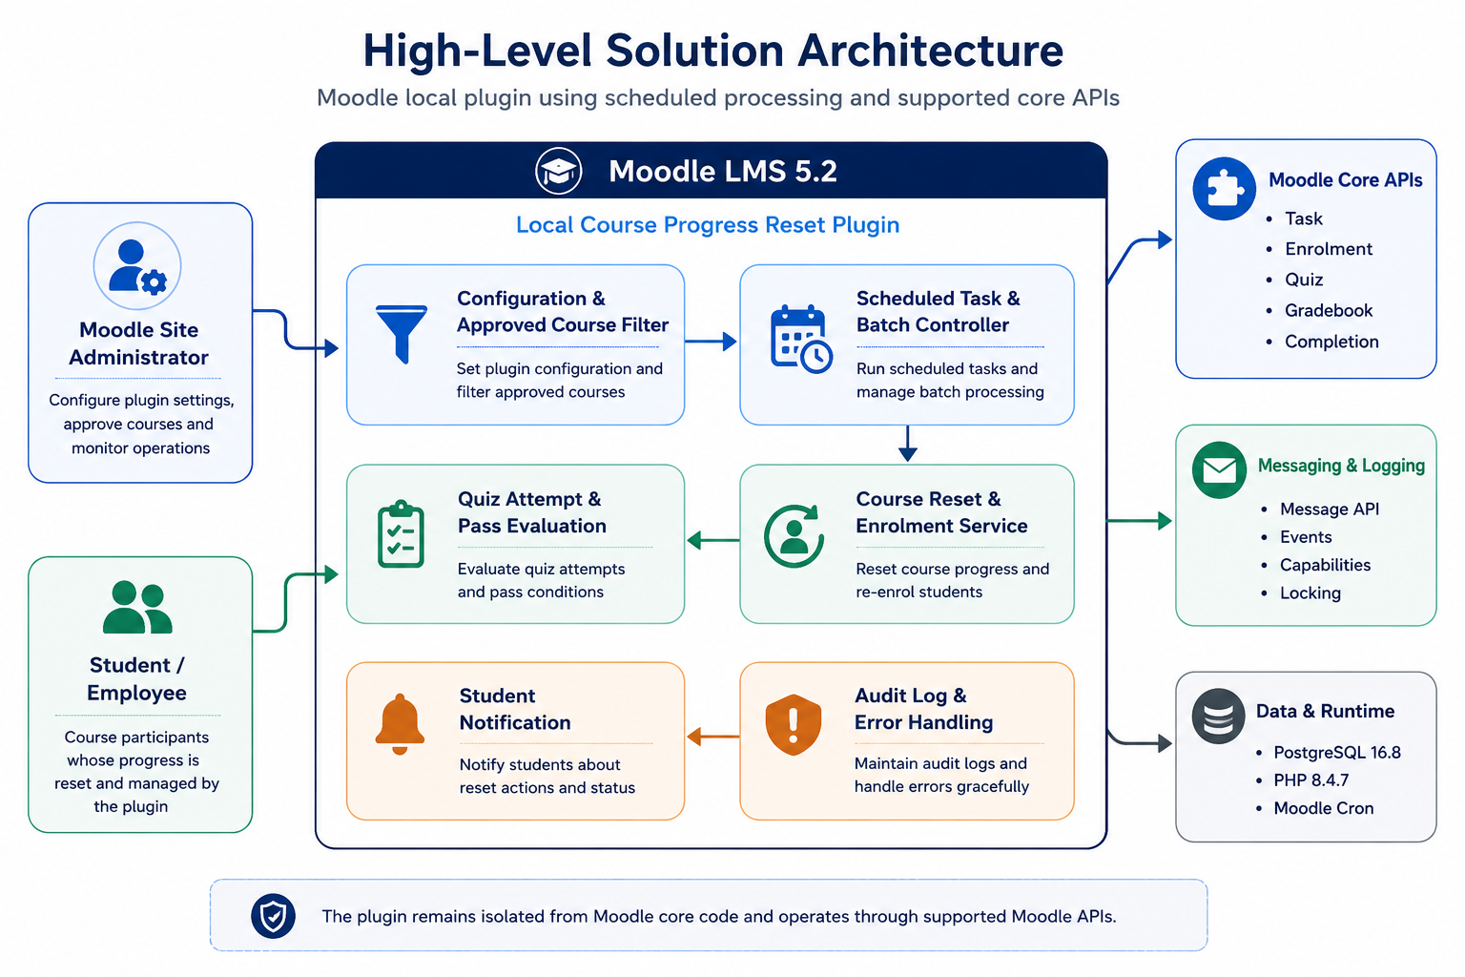
Figure 1. High-level architecture of the Moodle automatic course progress reset plugin.

8.2 Scheduled Task Processing Flow
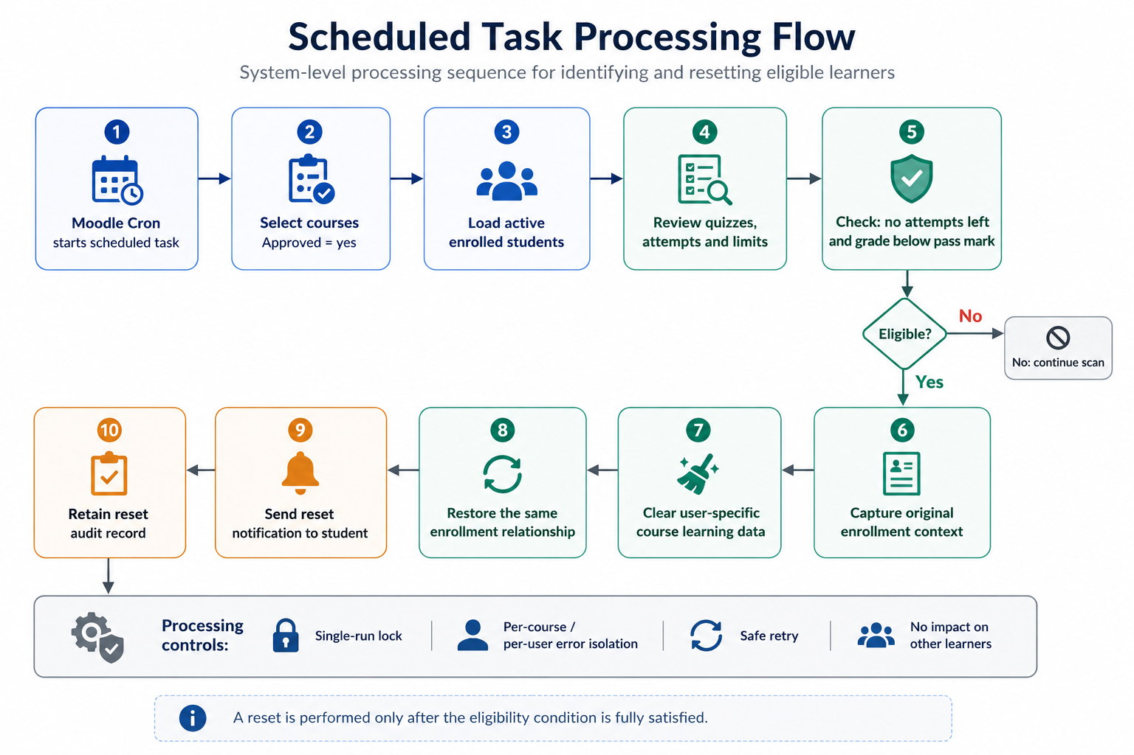
Figure 2. System processing flow from cron execution to audit completion.

9. Proposed Technical Stack
Layer | Proposed Technology | Purpose
LMS Platform | Moodle LMS 5.2 | Target platform and plugin runtime
Programming Language | PHP 8.4.7, 64-bit | Plugin services, scheduled task and Moodle API integration
Database | PostgreSQL 16.8 | Moodle data and plugin audit records
Plugin Type | Moodle Local Plugin | Site-level functionality without Moodle core modification
Background Runtime | Moodle Cron and Task API | Periodic automatic processing
Course Selection | Moodle Course Custom Fields | Select courses where Approved = yes
Learning APIs | Quiz, Gradebook, Activity Completion and Course Completion APIs | Attempt evaluation and learner progress reset
Enrolment | Moodle Enrolment API | Manual, Cohort and Cohort Sync continuity
Communication | Moodle Message API | Student reset notification
Audit and Control | Moodle Events/Logging, Access API and Lock API | Auditability, authorization and duplicate-run protection
Testing | Moodle PHPUnit, Behat/manual acceptance testing | Automated and staging quality validation
Version Control | Git | Source control and release packaging
Environment | Dedicated staging Moodle environment | Integration testing and QA before release

10. Development Methodology
A controlled iterative methodology will be used so that destructive reset behaviour is validated against real course structures before production release.
- Requirement Confirmation and Technical Discovery: Confirm field identifiers and stored values; inspect enrolment instances, quiz settings and installed course activity types; confirm audit and notification expectations.
- Technical Design: Finalize plugin structure, data handling, eligibility rules, enrolment adapters, reset sequence, error handling and test cases.
- Incremental Development: Implement course selection, scheduled processing, eligibility evaluation, reset services, enrolment continuity, notifications and audit logging in small verifiable increments.
- Developer and QA Validation: Run code review, static checks, unit tests, integration tests and regression tests using representative Moodle data.
- Staging Deployment and QA: Install in staging, execute controlled reset scenarios for each enrolment method, validate data integrity and obtain acceptance.
- Release and Handover: Prepare the installable package, documentation, release notes and production deployment checklist after staging approval.

11. Deliverables
• Installable Moodle local plugin package compatible with Moodle 5.2.
• Plugin source code following Moodle coding and plugin-structure standards.
• Scheduled task for automatic approved-course monitoring.
• Approved course custom-field selection logic.
• Quiz attempt and passing-grade eligibility engine.
• Full learner course progress reset service.
• Manual, Cohort and Cohort Sync enrolment continuity handling.
• Student reset notification through Moodle messaging.
• Reset audit logging and operational error logging.
• Automated test suite and documented manual/QA test scenarios.
• Staging deployment package and configuration checklist.
• Installation, configuration, operation and rollback documentation.
• Release notes and final deployment-ready plugin package.

12. Testing and Quality Assurance

12.1 Test Strategy
Testing will focus on eligibility accuracy, complete and isolated data reset, enrolment continuity, notification correctness and protection against partial or duplicate processing.

12.2 Unit Testing
• Approved-course selection using the exact custom field and value.
• Attempt-count comparison for below, equal to and above the maximum limit.
• Pass/fail determination against the quiz passing grade.
• Exclusion of quizzes with unlimited attempts.
• Candidate de-duplication and eligibility re-check logic.
• Audit record creation and notification payload generation.

12.3 Integration Testing
• Scheduled task execution through Moodle cron.
• Data reset for a learner with Manual enrolment.
• Data reset for a learner enrolled through Cohort enrolment.
• Data reset for a learner linked through Cohort Sync.
• Deletion of quiz attempts, grades, activity completion and course completion.
• Verification that another learner’s records remain unchanged.
• Verification that the learner remains enrolled and can access the course.
• Verification that previous grades are not restored after re-enrolment.
• Student-only notification delivery and restricted audit visibility.

12.4 Negative and Edge-Case Testing
• Learner has remaining quiz attempts.
• Learner has passed the quiz.
• Quiz has no passing grade configured.
• Quiz permits unlimited attempts.
• Course is not approved.
• Learner has multiple enrolment relationships.
• Cohort Sync executes during or after reset.
• Cron stops or a reset operation fails midway.
• The same learner is evaluated in consecutive task runs.
• A course contains third-party activities with custom user data.

12.5 Performance and Reliability Testing
• Run the task against representative numbers of courses, learners and quiz attempts in staging.
• Measure task duration, memory use and database load.
• Confirm batch processing and lock behaviour under repeated cron execution.
• Confirm that a single failure does not block unrelated courses or learners.
• Verify Moodle task retry and diagnostic output.

12.6 Security and Data Integrity Testing
• Verify that only authorized administrators can access settings and audit information.
• Verify that student users cannot access another user’s reset information.
• Verify that all data access uses Moodle DML and supported APIs.
• Verify that shared course content and other users’ data are not deleted.
• Verify that successful notification is not sent when the reset fails.
• Verify backup and rollback procedures before release.

13. Deployment and Release Approach
1. Create a backup of the staging database and Moodle data before installation.
2. Install the plugin in the confirmed Moodle 5.2 staging environment.
3. Configure or verify the Approved course field, cron operation and scheduled-task interval.
4. Run automated tests and controlled reset scenarios.
5. Complete QA and correct any identified defects.
6. Prepare the signed-off plugin package, release notes and deployment checklist.
7. Back up production before installation and deploy during an approved maintenance window.
8. Monitor the first scheduled runs, audit logs and notification results.
9. Use the documented rollback procedure if critical issues are identified.

14. Assumptions and Dependencies
• The target environment is Moodle 5.2 with PHP 8.4.7 and PostgreSQL 16.8.
• The Moodle application code, database access and a representative staging environment will be provided to the development team.
• Moodle cron is enabled and runs frequently enough to execute the configured scheduled task; Moodle recommends running cron at least once per minute.
• A course custom field named or identified as “Approved” exists, and its stored affirmative value is “yes”; the exact field shortname and value format will be confirmed during discovery.
• Each monitored quiz has a finite maximum attempt limit and a configured passing grade.
• The reset applies to active student/employee enrolments, not teachers, managers or site administrators.
• The existing Manual, Cohort and Cohort Sync enrolment instances are correctly configured.
• Moodle notification processors required by the client are already configured.
• The client will provide representative courses containing all relevant core and third-party activity types for compatibility testing.
• Backups and an approved maintenance window will be available for production deployment.
• Audit retention follows the existing client and Moodle log-retention configuration.

15. Out of Scope
• Changes to Moodle core code.
• UI/UX redesign of Moodle courses, dashboards or administration pages.
• A separate manual-reset screen, custom analytics dashboard or custom reporting portal.
• Reset triggers based on assignments, SCORM, attendance or criteria other than failed quizzes with exhausted attempts.
• Changes to quiz content, question banks, passing grades or attempt limits.
• Creation of new enrolment methods or modification of external source systems that manage cohorts.
• Mobile application development.
• New external integrations or custom notification channels outside existing Moodle messaging processors.
• Server migration, hosting changes, operating system changes or infrastructure redesign.
• Historical data migration or bulk remediation outside the scheduled reset process.
• Custom changes to third-party activity plugins that do not expose a supported user-data reset mechanism; such cases require separate technical assessment.

16. Acceptance Criteria
1. The plugin installs successfully on the confirmed Moodle 5.2 staging environment.
2. The scheduled task is visible and its execution frequency can be adjusted by an authorized administrator.
3. Only courses with Approved = yes are processed.
4. A learner is selected only when at least one quiz has no remaining attempts and the grade is below the passing grade.
5. Learners who passed, have remaining attempts or are in non-approved courses are not reset.
6. The eligible learner’s quiz attempts, grades, completion records and user-specific course progress are cleared.
7. The learner remains enrolled through the same intended enrolment relationship and retains the correct course role.
8. The learner sees 0% progress, no completed activities, no attempts and no grades after reset.
9. Only the affected student receives the reset notification.
10. Each success and failure is recorded in restricted audit logs.
11. Other learners and shared course content remain unchanged.
12. Manual, Cohort and Cohort Sync scenarios pass staging QA.
13. The final source package and operational documentation are delivered.

17. Conclusion
The proposed Moodle plugin will automate the identification and reset of failed course attempts, allowing eligible learners to restart the course with a clean academic record. The solution will be secure, auditable, compatible with the specified Moodle environment, and implemented with proper testing and staging validation

